QingKai Yi's personal profile

My personal information

My name is QingKai Yi and my student number is s3632505 , my email is s3632505@student.rmit.edu.au . I am an international student from North East of China .I have already spent 12 years for study , from primary school to middle school , high school and then come to Australia and study language and foundation , after that I get into RMIT university and study Information Technology . I can speak Chinese and English . I'm a fan of Warfare history , especially First and Second World War .I also like photography , taking photo of natural landscape is my favorite .

Interest in IT

My interest in IT is application programming .The opportunities for me to be interested in IT is because I watched many movies and games about programmers and hackers when I was young, at that time I was really curious about how those programmers can create successful applications and how hackers can hack into other's phone or PC and any other devices, that is magical !After some years , I realized that the magic programmers and hackers got is IT knowledge.

I studied some C++ programming and made an shopping program in foundation study and I also learn something about Networking , that is quite interesting when you think out how to fix the error and write the program .

The reason why I choose RMIT is because RMIT is famous for IT and my brother who has already graduated from university also suggested me to study in RMIT. During study in RMIT , I expect to learn more about programming, if there's possible，I also want to learn something about VR .I know it is hard , but I will try my best .

Ideal Job

This is my ideal job information and link address <https://www.seek.com.au/job/35735557?type=standard&userqueryid=12a45f18855a99cd3774cfd10a7542f7-8678774>

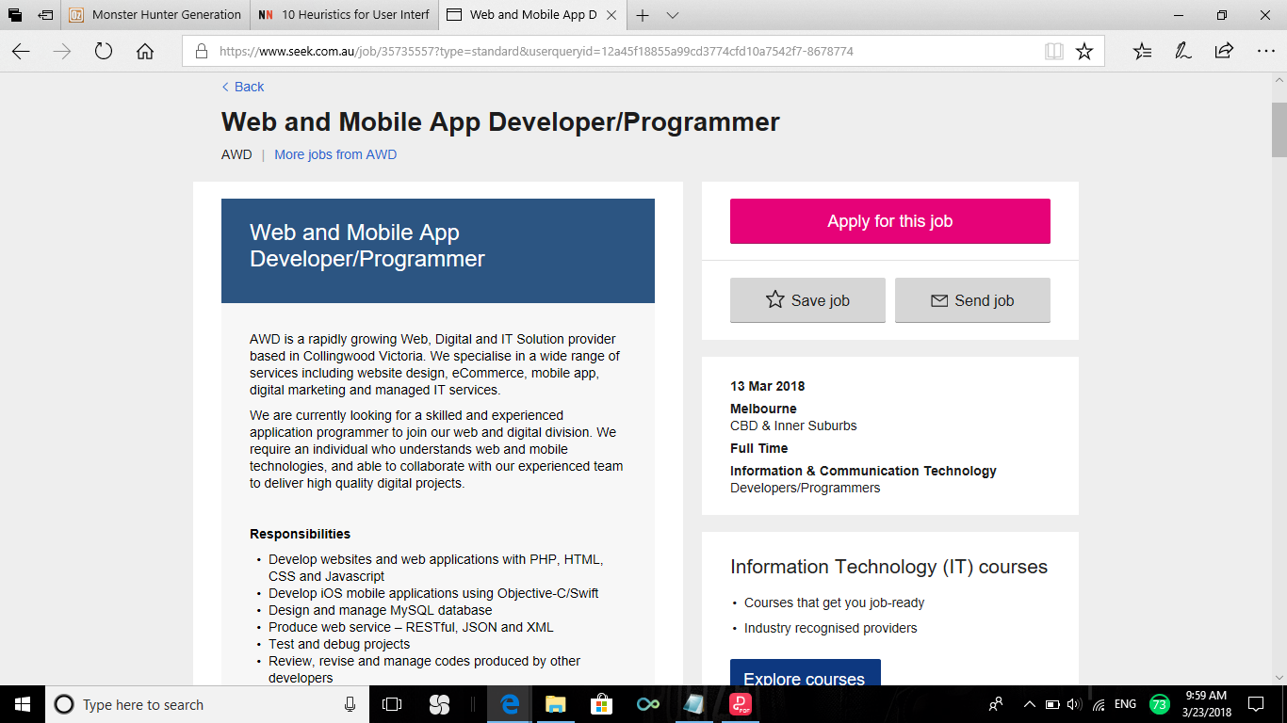

Job provider looking for some skilled and experienced application programmer to join their company. They need a programmer who understands web and mobile technologies, and able to cooperate with their experienced team to deliver high quality digital projects.

This job require 3+ years experience as a web and/or mobile developer and be proficient in PHP , MySQL, HTML,CSS and Javascript and many other experiences about programming and IT knowledge .

Right now I got some experiences about C++ and I started to learn Java . In my opinion , those two languages are quite same .I have some skills about making plans .As a starter of IT , I know I should learn more so I will choose application programming class and mobile system building class to study in the future and I will find some books and other learning materials to learn , hope that will give me a help for reaching the position I want to be .

Profile

This is my Myers-Briggs test result

Personality type: "The Mediator"

Individual traits:

Introverted---68%,

Intuitive---63%,

Feeling---68%,

Prospecting---64%,

Turbulent---58%,

Role: Diplomat

Strategy :Constant Improvement

This is my learning style test result

Auditory: 25%

Visual: 45%

Tactile: 30%

You are a Visual learner!

This is my Big Five Personality Test result

Openness 71%

Conscientiousness 52%

Extraversion 48%

Agreeableness 75%

Neuroticism 54%

These results mean a lot for me , they show me what is my weakness and what is my strong point and also they give me some encourage . From these results , I know that

I can let my group more energetic and coadjutant. The team spirit of my group will reach the top level . When forming a team, I will try to make best use of my advantages

and bypass the disadvantages to make my team running well.

Project Idea

This is an idea for mobile myki card , make it lighter , faster and easier to use . I am thinking about putting myki card into an app. In another words , I am planning to design an app for myki card thus passenger don’t need to bring myki card anymore , also I am planning to put more services on that app and make all the these things more convenient to passengers.

As a people who live in Melbourne , it is necessary to know about PTV . Public Transport Victoria is the most important transfer service in Victoria State. For me, an international student who study in RMIT city campus, it is the way I can get to university , generally speaking, my whole day’s life start at running for trains . Then, there come some problems , because some of my classes start at 8am , I am not pretty conscious at that time and I always forget to bring the card , when I realize that , I have already arrived at the station, so I need to run back to home and pick up the card then back to station again, after all of these , nearly 20 minutes has been wasted .However , I never forget my phone.

Another example is also from myself . Because some time my pocket is small and I put card inside with my phone , when I took out my phone , the Myki card also came out . It fell down to the ground and I did not know that because it is just a card ,it can not make loud noise to let me know . I just let that card out and fell , when I was on the train and I check my pocket , I can not feel my Myki card and I become stress . that is the most embarrassing thing during my study time . And at that time , I started to think about the idea about myki card : Can I made Myki card more easy to carry and do not lose it anymore ? Then, This mobile myki card idea has come out .

First , this Mobile Myki is a QR code , and it allow passengers who want to get into the station to open the QR code in their mobile phone and scan it (there will be new QR scanner on the gate.)This scanner is more sensitive than old scanning machine , passenger do not need to take out myki card from wallet or pocket anymore .

Second ，this Mobile Myki will not only have QR code .Passengers also can use recharge services , this will let passenger be quicker to top up their card , because after my observation I found out that during the rush time, passenger spent more than 10 minutes just for following a long line to recharge. This is a really wasting of time because everyone want to get into work place on time or go home early ,so in Mobile Myki, passengers can use this service same as they recharge their SIM card and the interface is same as recharge machines’ ,they can choose top up or put some cash in it . Also, there will be timetables in this application just the same as what PTV’s application did . This is a helpful service because I use timetable everyday, it let passengers check out when they need to catch the trains or trams so that they can organize their time.

In the end, there will be a service for credit. Many passenger forget to recharge their card before the expire day , we open this service for those passengers who really running for times , everyone can have ten times extra touch on credits before they top up the card , by the way , this credit service is not for free , that means passengers still need to pay for it when they recharge their card , because it is a credit so passenger need to pay a bit little higher price than usual .

As far as a I know, Skybus has print their ticket as a QR Code , we need the same technology as Skybus’s , or we can learn about commonwealth bank’s mobile app’s camera pay’s QR code, but it is QR code anyway , I think it is faster and easier just use the same type of QE code as Skybus’s. Finding some QR Code generators for making prototype QR code is not hard , but if we need a huge number of it and keep it secure, we need a professional group for making QR code . We also need to make a system as Optus mobile app for recharge system , so we can use master card paying system or Paypal paying system .Same as how other application be made group of developer is necessary and need many programmer to make it stable and check error frequently , we also need to check the flexibility for different type of phone so we need at least two phone , one is Android system phone, another is IOS . Then we need voluntary to test it and collect the feedback from them then improve and perfect the application .

If this project make successful , it will make Melbourne even the whole Victoria State get into a faster transport era , it will solve the passengers’ long time waiting problem and losing issue, quicker recharge service will let passenger be more comfortable, also with credit service , more passengers who does not mean to sneak through without a ticket will not be punished by officer , more humanized service is never a bad idea .